RECRUITING ASSISTANT FOR

HR MANAGERS

INTRODUCTION

The human resources are the most important assets of an organization. The success or failure of an organization is largely dependent on the caliber of the people working there in. Without positive and creative contributions from people, organizations cannot progress and prosper. In order to achieve the goals or the activities of an organization, therefore, they need to recruit people with requisite skills, qualifications and experience. While doing so, they have to keep the present as well as the future requirements of the organization in mind.

Recruitment is distinct from Employment and Selection. Once the required number and kind of human resources are determined, the management has to find the places where the required human resources are/will be available and also find the means of attracting them towards the organization before selecting suitable candidates for jobs. All this process is generally known as recruitment. Some people use the term “Recruitment” for employment. These two are not one and the same. Recruitment is only one of the steps in the entire employment process. Some others use the term recruitment for selection. These are not the same either. Technically speaking, the function of recruitment precedes the selection function and it includes only finding, developing the sources of prospective employees and attracting them to apply for jobs in an organization, whereas the selection is the process of finding out the most suitable candidate to the job out of the candidates attracted (i.e., recruited).Formal definition of recruitment would give clear cut idea about the function of recruitment.

IT Recruitment is recruitment of IT Professionals for various IT Skill sets like Software Developers, Database Administrators, System and Networking Engg etc at various levels i.e. junior middle and senior positions.   
Hiring a professional by first understanding the exact skill set and then matching it with the various applicants resumes and then short listing and screening the best fit out of the lot is what is required. understanding of all the IT technology is must and other determining factors like education background certifications skills and domain type of industry work experience etc for hiring or recruiting a right professional.

PURPOSE AND IMPORTANCE:

The general purpose of recruitment is to provide a pool of potentially qualified job candidates. Specifically, the purposes are to:

* Determine the present and future requirements of the organization in conjunction with its personnel-planning and job-analysis activities.
* Increase the pool of job candidates at minimum cost.
* Help increase the success rate of the selection process by reducing the number of visibly, under qualified or overqualified job applicants.
* Help reduce the probability that job applicants, once recruited and selected, will leave the organization only after a short period of time.
* Begin identifying and preparing potential job applicants who will be appropriate candidates.
* Induct outsiders with a new perspective to lead the company.
* Develop an organizational culture that attracts competent people to the company.
* Search or head hunt/head pouch people whose skills fit the company’s values.
* Devise methodologies for assessing psychological traits.
* Search for talent globally and not just within the company.
* Design entry pay that competes on quality but not on quantum.
* Anticipate and find people for positions that do not exist yet.
* Increase organizational and individual effectiveness in the short term and long term.
* Evaluate the effectiveness of various recruiting techniques and sources for all types of job applicants.

PROBLEM DEFINITION & DESIGN THINKING:

Empathy Map

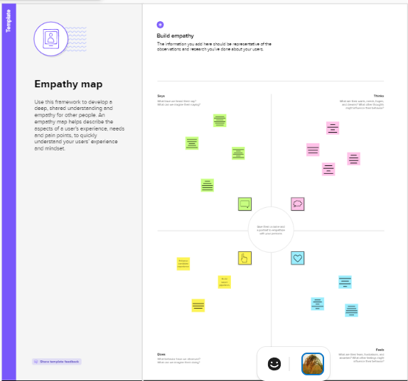

Ideation & Brainstorming Map

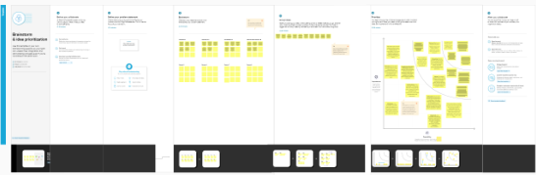

|  |  |  |
| --- | --- | --- |
| OBJECT NAME | FIELD | FIELD NAME |
| Job Posting Site  Review | Label  Name | Status  Technical site  Description |

Result:

Activity & Screenshot:

Creating Developer Account:

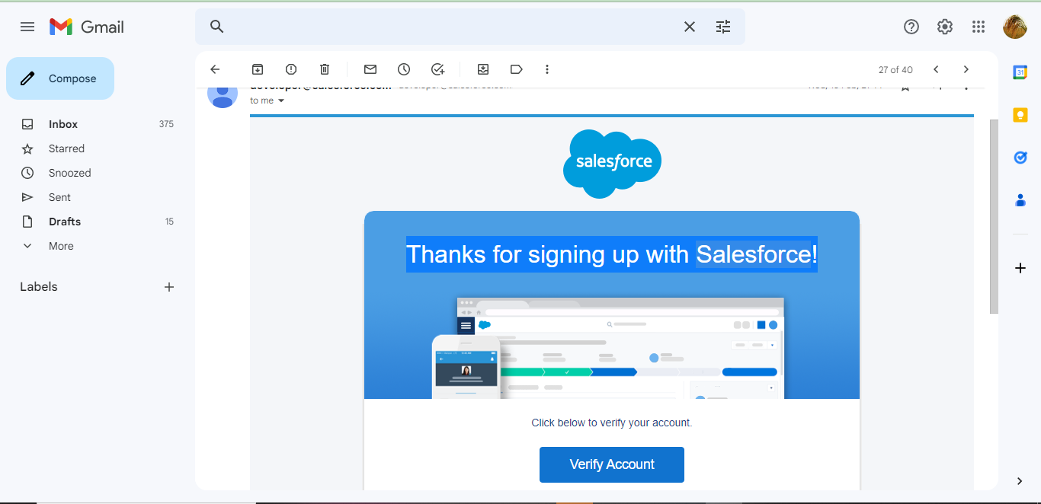

Using this <https://developer.salesforce.com/> link we signup the salesforce platform and finally we get the verification mail that shown in the above figure.

Salesforce Login:

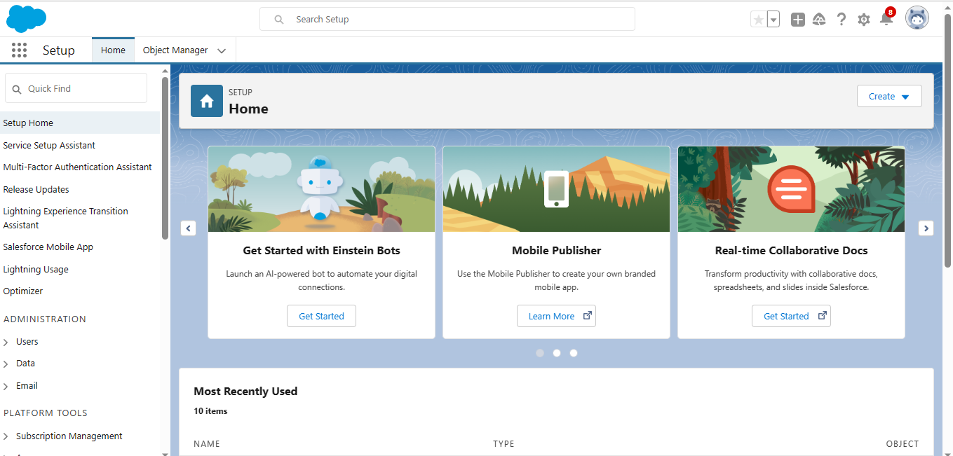

<https://login.salesforce.com/> we used this link to login the salesforce platform. This link asked our username and password only.

Package installation for Recruiting app:

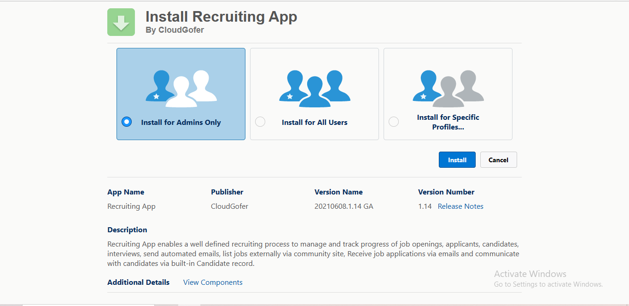

To install a package, an administrator can navigate to the app exchange, find the desired package, and click the “Install” button.

Object:

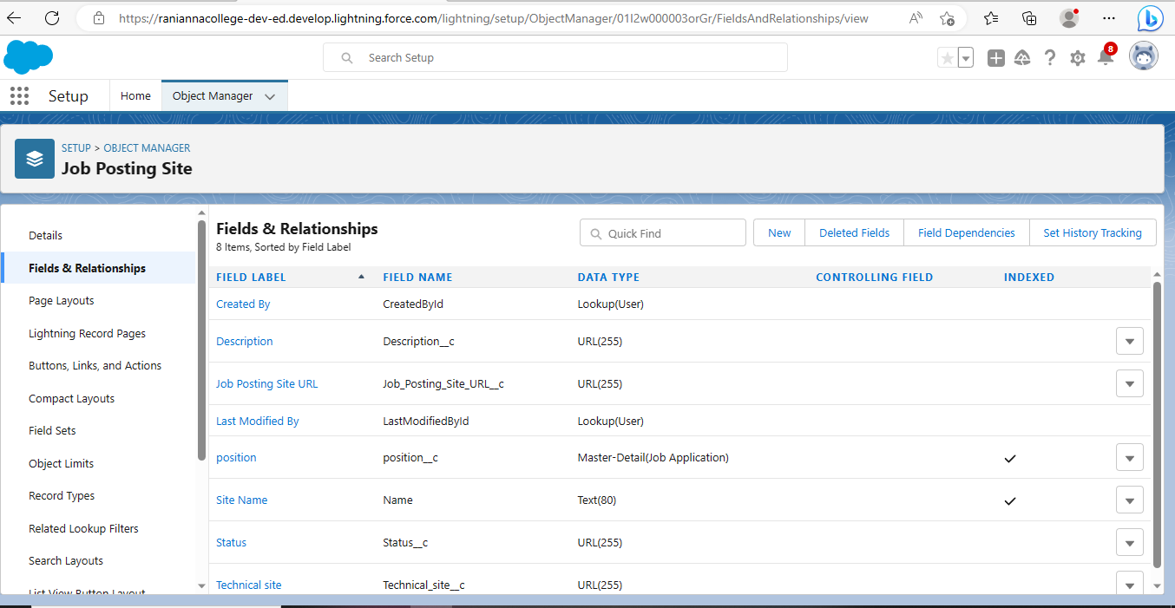

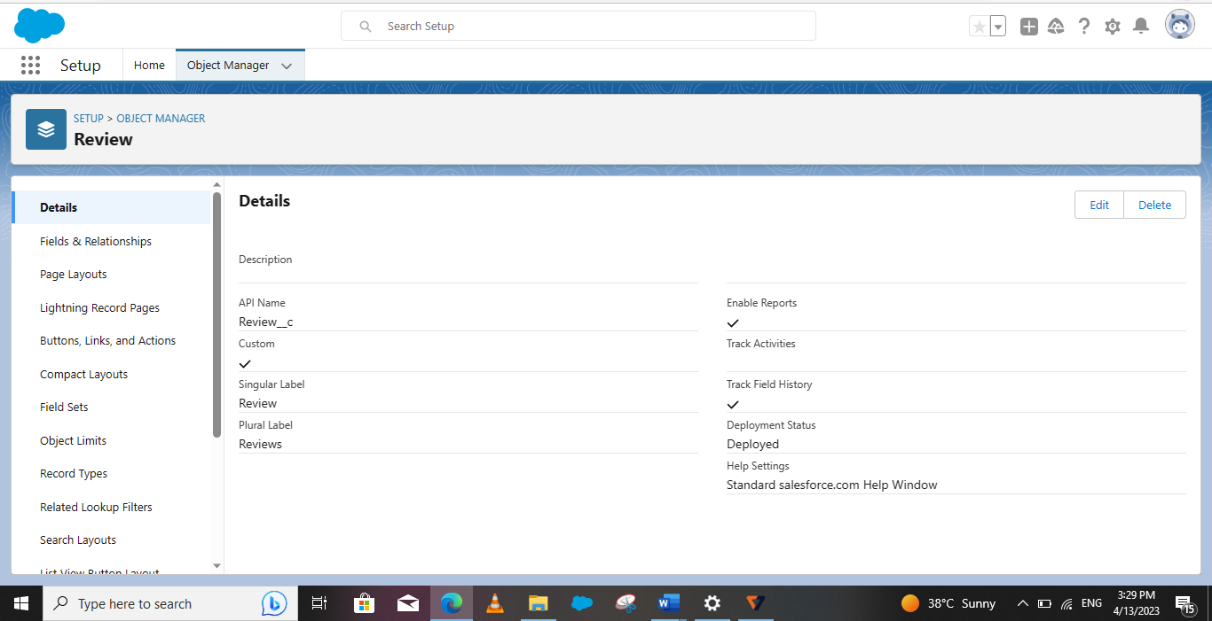

For this HR Management project we created 2 objects. They are Job posting sites object and Review object.

Tab:

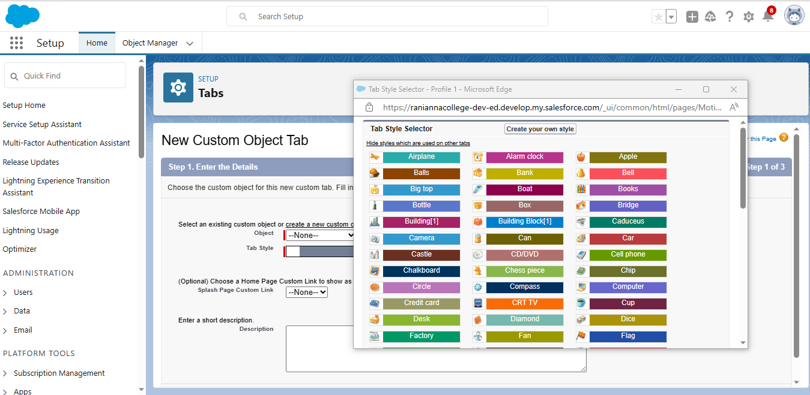

In Salesforce, a tab is a user interface element that allows users to navigate to different sections of the platform, such as Account, Contacts, Leads, and Opportunities. Tabs can also be used to access custom object and custom pages. They are typically located at the top of the screen and can be customized to fit the needs of the organization.

Fields:



Fields in Salesforce represents what the columns represent in relational databases. It can store data values which are required for a particular object in a record.

Page Layout:

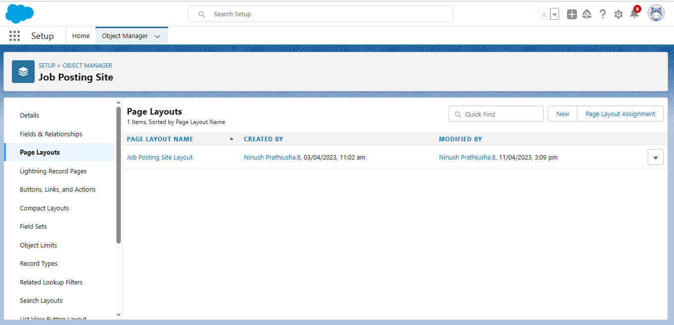

Page Layouts can be customized to show the fields and related information that are most relevant to different users, roles, and record types. They can also be used to control the visibility and access to fields, buttons, and other components on a page.

Validation Rules:

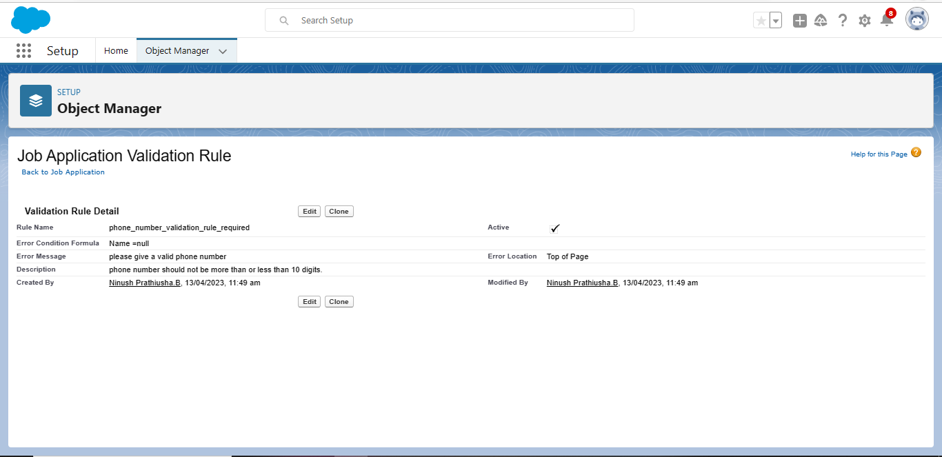

A validation rule is a process which checks out (validate) the inputs given by any user is correct or not according to a requirement.

Profiles:

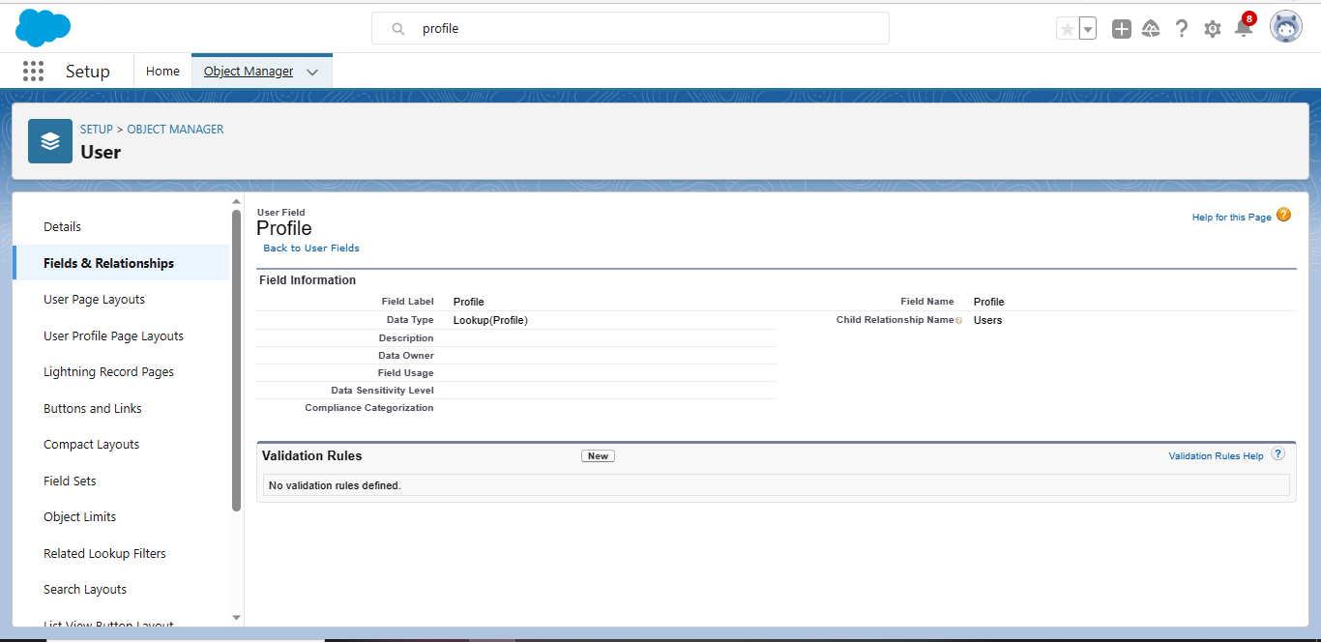

A profile is a group/collection of settings and permissions that define what a user can do in salesforce. A profile can be assigned to many users, but user can be assigned single profile at a time.

User:

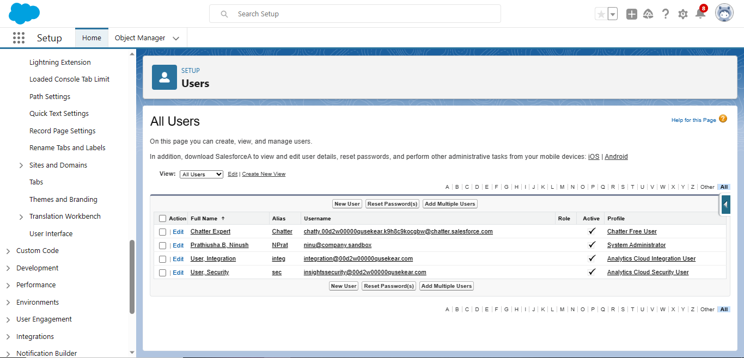

A user is anyone who logs in to Salesforce. Users are employees at your company, such as sales reps, managers, and IT specialists, who need access to the company’s records. Every user in Salesforce has a user account. The user account identifies the user, and the user account settings determine what features and records the users can access.

Permission Set:

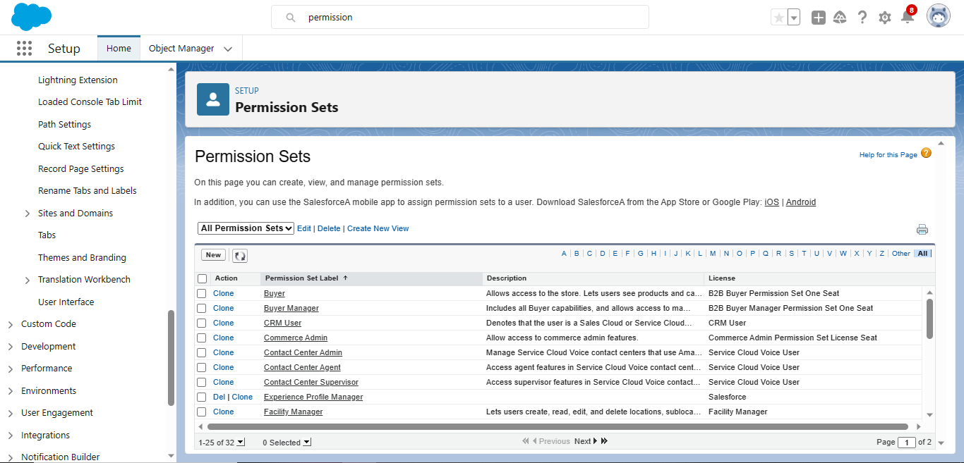

Permission sets can be used to grant additional access to users beyond what is included in the profile, without modifying the profile itself. Permission sets can be assigned to individual users or to a group of users.

Reports:

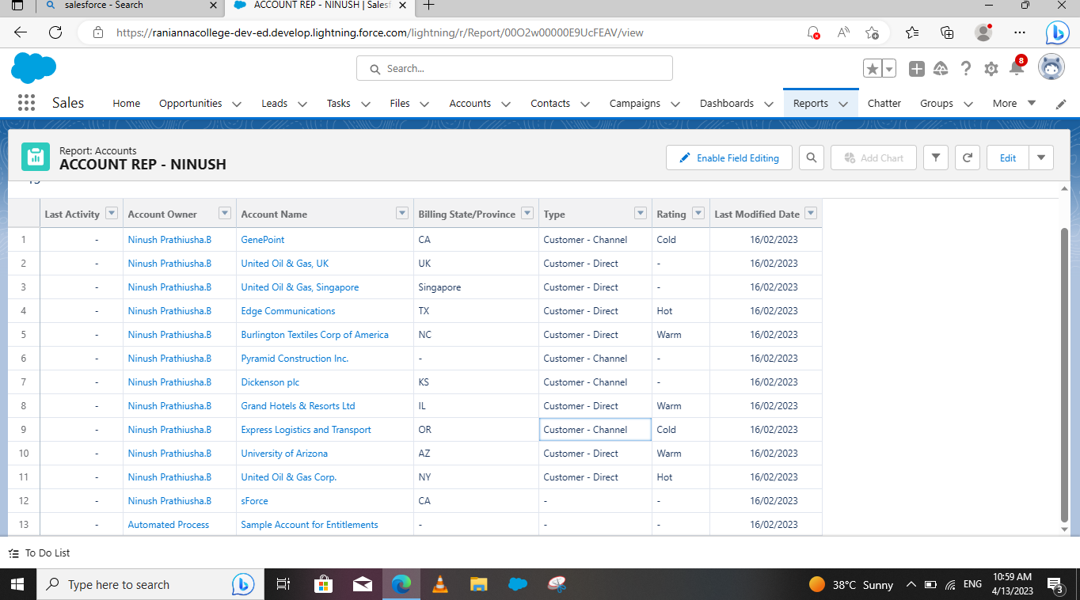

A report is a list of records that need the criteria you define. It’s displayed in rows and columns, and can be filtered, grouped, or displayed in a graphical chart.

Trailhead Profile Public URL:

Team lead: <https://trailblazer.me/id/roshr11>

Team member 1: <https://trailblazer.me/id/anuss35>

Team member 2: <https://trailblazer.me/id/kalig10>

Team member 3: <https://trailblazer.me/id/nprathiushab>

Advantages & Disadvantage

Advantage:

* Gives existing employees greater opportunity to advance their careers in the business.
* May help to retain staff who might otherwise leave.
* Requires a short induction training period.
* Employer should know more about the internal candidate’s abilities.
* Usually quicker and less expensive than recruiting from outside.

Disadvantages:

* Limits the number of potential applicants for a job.
* External candidates might be better suited /qualified for the job.
* Another vacancy will be created that has to be filled.
* Existing staff may feel they have the automatic right to be promoted, whether or not they are competent.
* Business may become resistant to change: by recruiting from outside, new perspectives attitudes are brought in.

Applications:

· Personal data (address, sex, telephone number)

· Marital data

· Educational data

· Employment Experience

· Extra-curricular activities

· References and Recommendations

Conclusion:

1. The companies follows a standard policy to recruit employees

2. The existing recruitment policy is adequate to recruit various types of personnel but modern methods of recruitment and selection should be adopted to be more effective.

3. The present recruitment policy is flexible enough as it has undergone several changes from time to time to suit the requirements of the management.

4. In the companies, both internal & external sources of recruitment are used.

Future Scope:

This research objective is to provide better understanding in the relationship of effectiveness of Human resource functions. It will provide useful information of relationship between employee retention and employee compensation, appraisal system, employee empowerment and employee training. This will help the company either to make any kind of improvements in the functions of the Human resources department or to retain their way of handling for better performance by obtaining full productivity from the employees for achieving the goals of the organization.